Bandit0 ZjLjTmM6FvvyRnrb2rfNWOZOTa6ip5If
bandit1 263JGJPfgU6LtdEvgfWU1XP5yac29mFx
bandit2 MNk8KNH3Usiio41PRUEoDFPqfxLPlSmx
bandit3 2WmrDFRmJIq3IPxneAaMGhap0pFhF3NJ
bandit4 4oQYVPkxZOOEOO5pTW81FB8j8lxXGUQw
bandit5 HWasnPhtq9AVKe0dmk45nxy20cvUa6EG
bandit6 morbNTDkSW6jIlUc0ymOdMaLnOlFVAaj
bandit7 dfwvzFQi4mU0wfNbFOe9RoWskMLg7eEc
bandit8 4CKMh1JI91bUIZZPXDqGanal4xvAg0JM
bandit9 FGUW5ilLVJrxX9kMYMmlN4MgbpfMiqey
bandit10 dtR173fZKb0RRsDFSGsg2RWnpNVj3qRr
bandit11 7x16WNeHIi5YkIhWsfFIqoognUTyj9Q4
bandit12 FO5dwFsc0cbaIiH0h8J2eUks2vdTDwAn

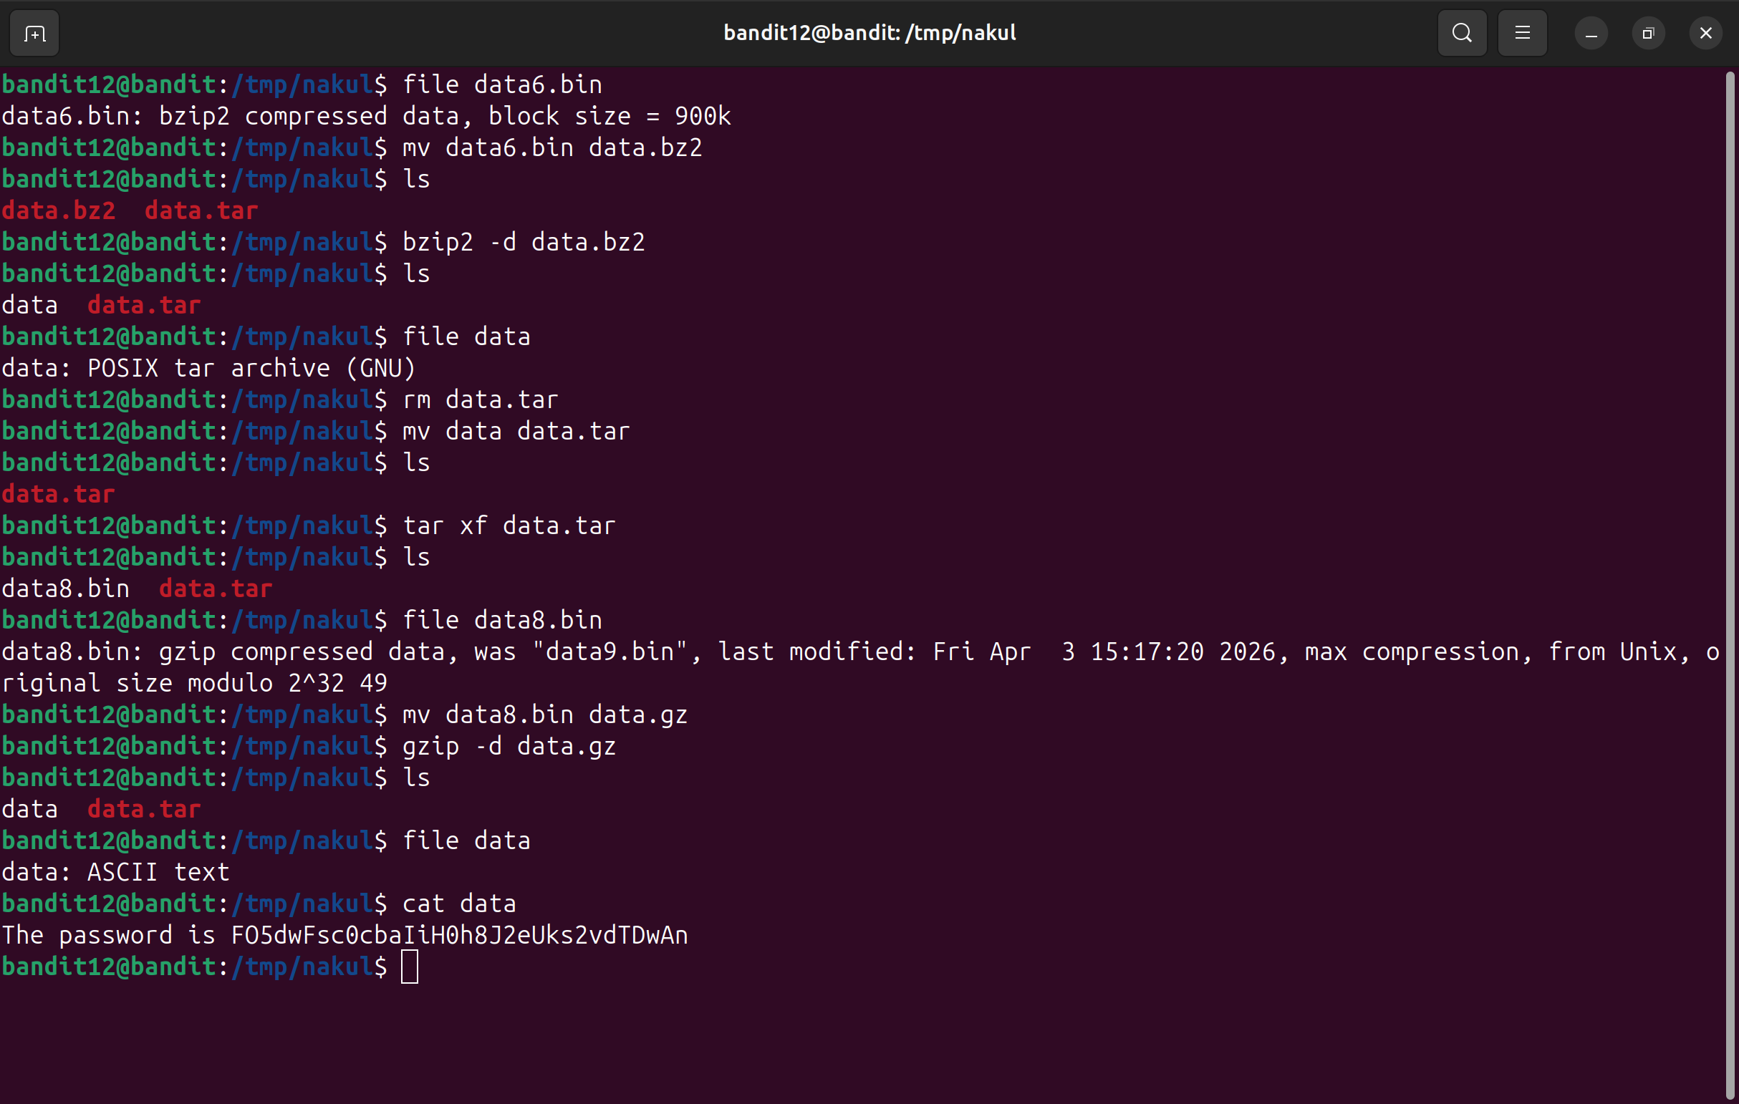
---

bandit13
bandit14 8xCjnmgoKbGLhHFAZlGE5Tmu4M2tKJQo
bandit15 kSkvUpMQ7lBYyCM4GBPvCvT1BfWRy0Dx
bandit16 I entered bandit17 with the help of vim
bandit17 x2gLTTjFwMOhQ8oWNbMN362QKxfRqGlO
bandit18 cGWpMaKXVwDUNgPAVJbWYuGHVn9zl3j8
bandit19 0qXahG8ZjOVMN9Ghs7iOWsCfZyXOUbYO
bandit20 EeoULMCra2q0dSkYj561DX7s1CpBuOBt
bandit21 tRae0UfB9v0UzbCdn9cY0gQnds9GF58Q
bandit22 0Zf11ioIjMVN551jX3CmStKLYqjk54Ga
bandit23 gb8KRRCsshuZXI0tUuR6ypOFjiZbf3G8

bandit24 iCi86ttT4KSNe1armKiwbQNmB3YJP3q4
bandit25

